# INTRODUCTION

JavaScript is the dominant client-side scripting language of the Web, with 95% of websites using it for this purpose. Scripts are embedded in or included

from HTML documents and interact with the DOM. All major web browsers have a built- in JavaScript engine that executes the code on the user's device.

The use of JavaScript has expanded beyond its web browser roots. JavaScript engines are now embedded in a variety of other software systems, both for server-side website deployments and non-browser applications.

Initial attempts at promoting server-side JavaScript usage were Netscape Enterprise

Server and Microsoft's Internet Information Services, but they were small niches. Server-side usage eventually started to grow in the late-2000s, with the creation of Node.js and other approaches.

Electron, Cordova, and other software frameworks have been used to create many applications with behaviour implemented in JavaScript. Other non-browser applications include Adobe Acrobat support for scripting PDF documents and GNOME Shell extensions written in JavaScript.

JavaScript has recently begun to appear in some embedded systems, usually by leveraging Node.js.

Alongside HTML and CSS, JavaScript is one of the core technologies of the World Wide Web. JavaScript enables interactive web pages and is an essential part of web applications. The vast majority of websites use it for client-side page behaviour, and all major web browsers have a dedicated JavaScript engine to execute it.

As a multi-paradigm language, JavaScript supports event-driven, functional,

and imperative programming styles. It has application programming interfaces (APIs) for working with text, dates, regular expressions, standard data structures, and the Document Object Model (DOM). However, the language itself does not include any input/output (I/O), such as networking, storage, or graphics facilities, as the host environment (usually a web browser) provides those APIs.

JavaScript engines were originally used only in web browsers, but they are now embedded in some servers, usually via Node.js. They are also embedded in a variety of applications created with frameworks such as Electron and Cordova.

Although there are similarities between JavaScript and Java, including language

name, syntax, and respective standard libraries, the two languages are distinct and differ greatly in design.

**Web design**

web design encompasses many different skills and disciplines in the production and maintenance of websites. The different areas of web design include web graphic design; user interface design (UI design); authoring, including standardised code and proprietary software; user experience design (UX design); and search engine optimization. Often many individuals will work in teams covering different aspects of the design process, although some designers will cover them all. The term "web design" is normally used to describe the design process relating to the front-end (client side) design of a website including

writing mark up. Web design partially overlaps web engineering in the broader scope of web development. Web designers are expected to have an awareness of usability and if their role involves creating mark up then they are also expected to be up to date with web

accessibility guidelines.

**Tools and Technologies**

Web designers use a variety of different tools depending on what part of the production process they are involved in. These tools are updated over time by newer standards and software but the principles behind them remain the same. Web designers use

both vector and raster graphics editors to create web-formatted imagery or design prototypes. Technologies used to create websites include W3C standards like HTML and CSS, which can be hand-coded or generated by WYSIWYG editing software. Other tools web designers might use include mark up validators and other testing tools for usability and accessibility to ensure their websites meet web accessibility guidelines.

**Marketing and communication design**

Marketing and communication design on a website may identify what works for its target market. This can be an age group or particular strand of culture; thus, the designer may understand the trends of its audience. Designers may also understand the type of website they are designing, meaning, for example, that (B2B) business-to-business website design considerations might differ greatly from a consumer targeted website such as a retail or entertainment website. Careful consideration might be made to ensure that the aesthetics or overall design of a site do not clash with the clarity and accuracy of the content or the ease

of web navigation, especially on a B2B website. Designers may also consider the reputation of the owner or business the site is representing to make sure they are portrayed favourably.

TITLE: TOURS AND TAVELS

Here we have developed a project on Tour and Travel. Online Tour and Travel Booking is a system that gives you the facility of booking any type of packages. This system is made, so that customer can easily book ticket for all packages of tourist places such as hills, trekking, adventures, spirituals. The project ‘Tours and Travels’ is developed to replace the currently existing system, which helps in keeping records of the customer, details of destination as well as payment received. Payment gateway is also available in this site.

The objective of the project is to develop a system that automates the processes and activities of a travel and. The purpose is to design a system using which one can perform all operations related to traveling.

SOURCE CODE

**Main page of website booking page:( Index page)**

<!DOCTYPE html>

<html>

<head>

<meta http-equiv="X-UA-Compatible" content="IE=edge,chrome=2" />

<title>Tours & Travels</title>

<meta name="description" content="" />

<meta name="viewport" content="width=device-width, initial-scale=1" />

</head>

<script type="text/javascript"> function showokay(){

alert("Your tickets have been booked, please check your respective mail for tickets. Thankyou for booking with Explore Travels and Tours! Wish you a h appy journey ");

}

</script>

<body>

<section class="banner" id="bottom">

<div class="container">

<div class="row">

<div class="col-md-1">

<div class="flex">

<div class="right-side">

<div class="logo">

<img src="img/logo.jpeg" />

</div>

<div class="page-direction-button">

<a href="contact.html"

><i class="fa fa-phone"></i>Contact Us Now</a

>

</div>

</div>

</div>

</div>

<div class="col-md-5 col-md-offset-5">

<div class="submit-form">

<h4>Check availability for <em>travel package</em>:</h4>

<form id="form-submit" action="" method="get">

<div class="row">

<div class="col-md-6">

<fieldset>

<label for="from">From:</label>

<select required name="from" onchange="this.form()">

<option value="">Select a location...</option>

<option value="Cambodia">Cambodia</option>

<option value="Hong Kong">Hong Kong</option>

<option value="India">India</option>

<option value="Japan">Japan</option>

<option value="Korea">Korea</option>

<option value="Laos">Laos</option>

<option value="Myanmar">Myanmar</option>

<option value="Singapore">Singapore</option>

<option value="Thailand">Thailand</option>

<option value="Vietnam">Vietnam</option>

</select>

</fieldset>

</div>

<div class="col-md-6">

<fieldset>

<label for="to">To:</label>

<select required name="to" onchange="this.form()">

<option value="">Select a location...</option>

<option value="Cambodia">Cambodia</option>

<option value="Hong Kong">Hong Kong</option>

<option value="India">India</option>

<option value="Japan">Japan</option>

<option value="Korea">Korea</option>

<option value="Laos">Laos</option>

<option value="Myanmar">Myanmar</option>

<option value="Singapore">Singapore</option>

<option value="Thailand">Thailand</option>

<option value="Vietnam">Vietnam</option>

</select>

</fieldset>

</div>

<div class="col-md-6">

<fieldset>

<label for="departure">Departure date:</label>

<input

name="deparure" type="date"

class="form-control date" id="deparure"

placeholder="Select date..." required="" onchange="this.form()"

/>

</fieldset>

</div>

<div class="col-md-6">

<fieldset>

<label for="return">Return date:</label>

<input

name="return" type="date"

class="form-control date" id="return" placeholder="Select date..." required="" onchange="this.form()"

/>

</fieldset>

</div>

<div class="col-md-6">

<div class="radio-select">

<div class="row">

<div class="col-md-6 col-sm-6 col-xs-6">

<label for="round">Round</label>

<input

type="radio" name="trip" id="round" value="round" required="required" onchange="this.form()"

/>

</div>

<div class="col-md-6 col-sm-6 col-xs-6">

<label for="oneway">Oneway</label>

<input

type="radio" name="trip" id="oneway" value="one-way" required="required" onchange="this.form()"

/>

</div>

</div>

</div>

</div>

<div class="package-button">

<fieldset>

<button type="submit" id="form- submit" class="btn" onclick="showokay()">

Book Package

</button>

</fieldset>

</div>

</div>

</form>

</div>

</div>

</div>

</div>

</div>

</section>

</body>

</html>

**Contact page 2nd page:(Contact Us Page)**

<!DOCTYPE html>

<html>

<head>

<meta charset="utf-8">

<title> Contact Us Page</title>

<meta name="description" content="">

<meta name="viewport" content="width=device-width, initial-scale=1">

</head>

<body>

<section class="page-heading" id="bottom">

<div class="container">

<div class="row">

<div class="col-md-2">

<div class="logo">

<img src="img/logo.jpeg" >

</div>

</div>

<div class="col-md-6">

<div class="page-direction-button">

<a href="index.html"><i class="fa fa- home"></i>Go Back Home</a>

</div>

</div>

</div>

</div>

</section>

<section class="contact-us">

<div class="container">

<div class="row">

<div class="col-md-12">

<div class="section-heading">

<h2>Contact Information</h2>

<p>

</p>

</div>

</div>

<div class="col-md-6">

<img src="img/j.jpeg" alt="">

</div>

<div class="col-md-6">

<img src="img/k.jpeg" alt="">

</div>

<div class="col-md-4">

<h6>Travellers History</h6>

<p>Travel dates back to antiquity where wealthy Greeks and Romans would travel for leisure to their summer homes and villas in cities su ch as Pompeii and Baiae. While early travel tended to be slower, more dangerou s, and more dominated by trade and migration, cultural and technological advan ces over many years have tended to mean that travel has become easier and more accessible. Mankind has come a long way in transportation since Christopher C olumbus sailed to the new world from Spain in 1492, an expedition which took o ver 10 weeks to arrive at the final destination; to the 21st century where air craft allow travel from Spain to the United States overnight.</p>

</div>

<div class="col-md-4">

<h6>Meet the Nature, find yourself</h6>

<p>Authorities emphasize the importance of taking precauti ons to ensure travel safety. When traveling abroad, the odds favor a safe and incident-

free trip, however, travelers can be subject to difficulties, crime and violen ce. Some safety considerations include being aware of one's surroundings,avoid ing being the target of a crime, leaving copies of one's passport and itinerar y information with trusted people, obtaining medical insurance valid in the co untry being visited and registering with one's national embassy when arriving in a foreign country. Many countries do not recognize drivers' licenses from o ther countries; however most countries accept international driving permits.</ p>

</div>

<div class="col-md-4">

<h6> Science learning with tourism and traveling</h6>

<p>Science tourism is a travel topic grouping scientific a ttractions. It covers interests in visiting and exploring scientific landmarks

, including museums, laboratories, observatories and universities.[1][2] It al so includes visits to see events of scientific interest, such as solar eclipse.

</p>

</div>

</div>

</div>

</section>

<section class="contact-form">

<div class="container">

<div class="row">

<div class="col-md-12">

<div class="section-heading">

<h2>Leave us a message</h2>

</div>

</div>

<div class="col-md-6 col-md-offset-3">

<form id="contact" action="#" method="post">

<div class="row">

<div class="col-md-6">

<fieldset>

<input name="name" type="text" class="form

-control" id="name" placeholder="Your name..." required="">

</fieldset>

</div>

<div class="col-md-6">

<fieldset>

<input name="email" type="text" class="for m-control" id="email" placeholder="Your email..." required="">

</fieldset>

</div>

<div class="col-md-12">

<fieldset>

<textarea name="message" rows="6" class=

"form-

control" id="message" placeholder="Your message..." required=""></textarea>

</fieldset>

</div>

<div class="col-md-12">

<fieldset>

<button type="submit" id="form-submit" class="btn">Submit Your Message</button>

</fieldset>

</div>

</div>

</form>

</div>

</div>

</div>

</section>

</body>

</html>

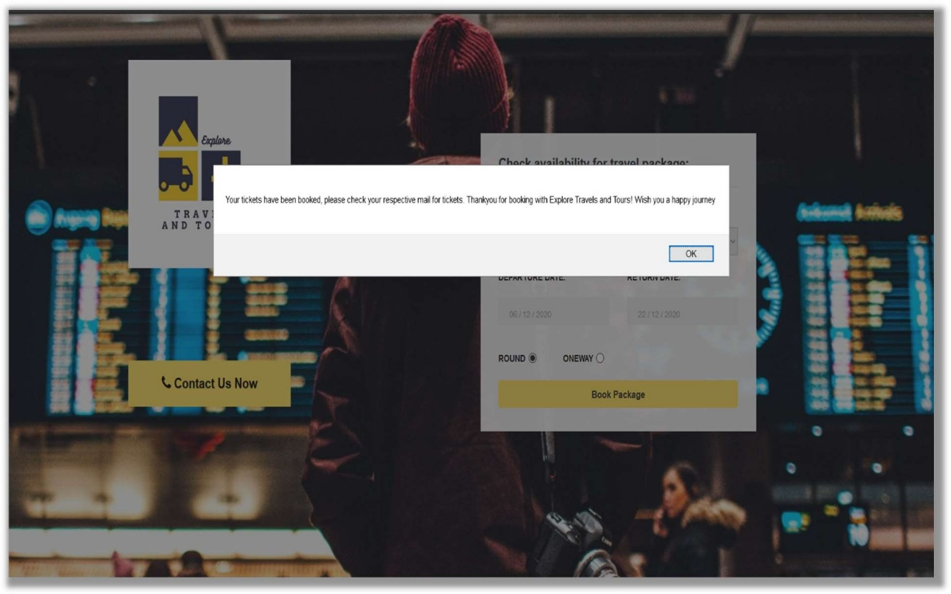

# CODE OUTPUT:

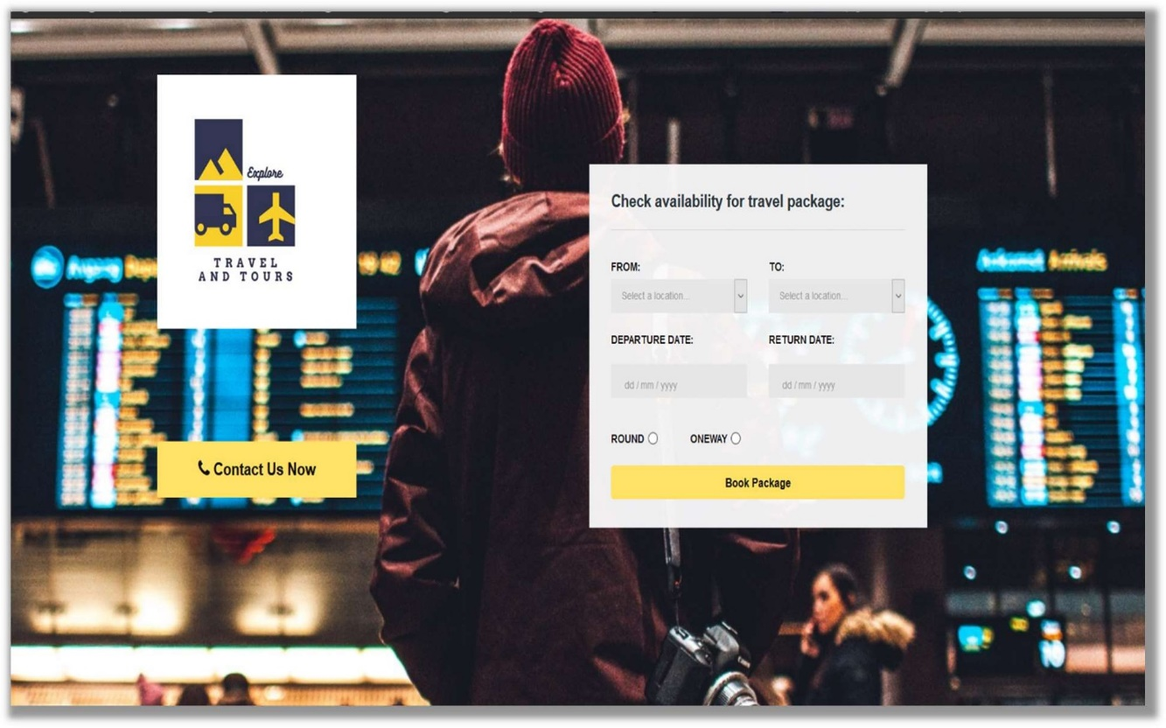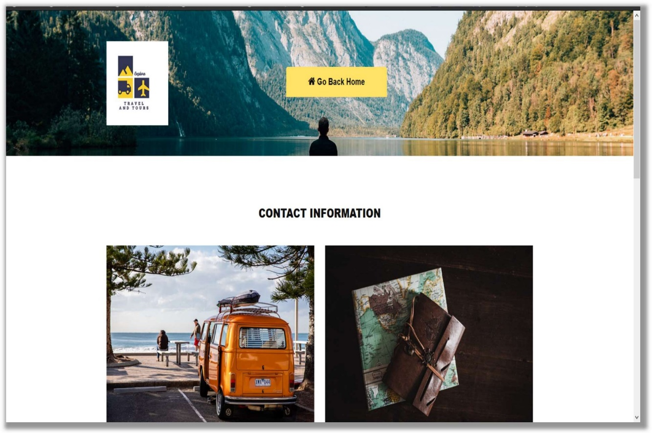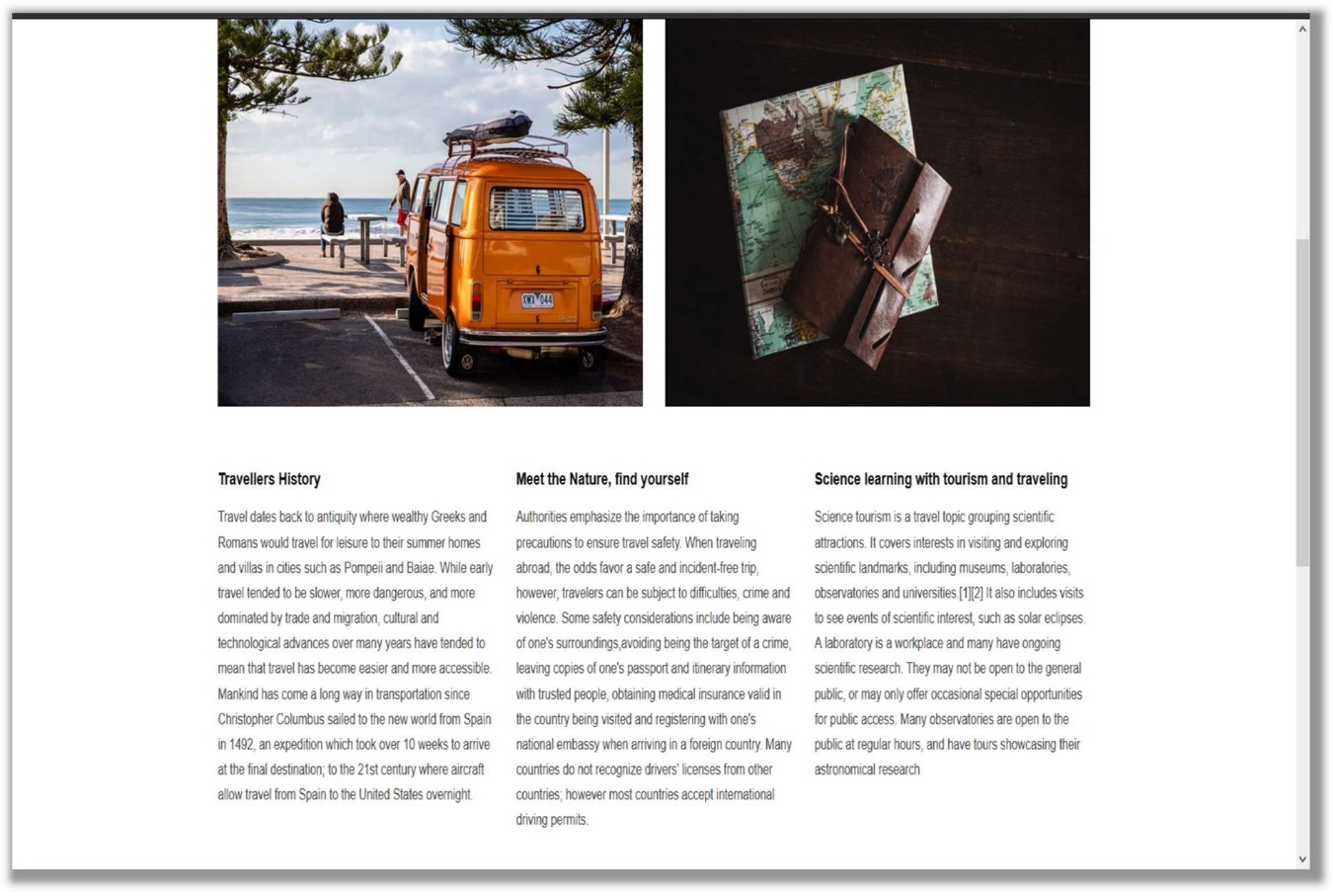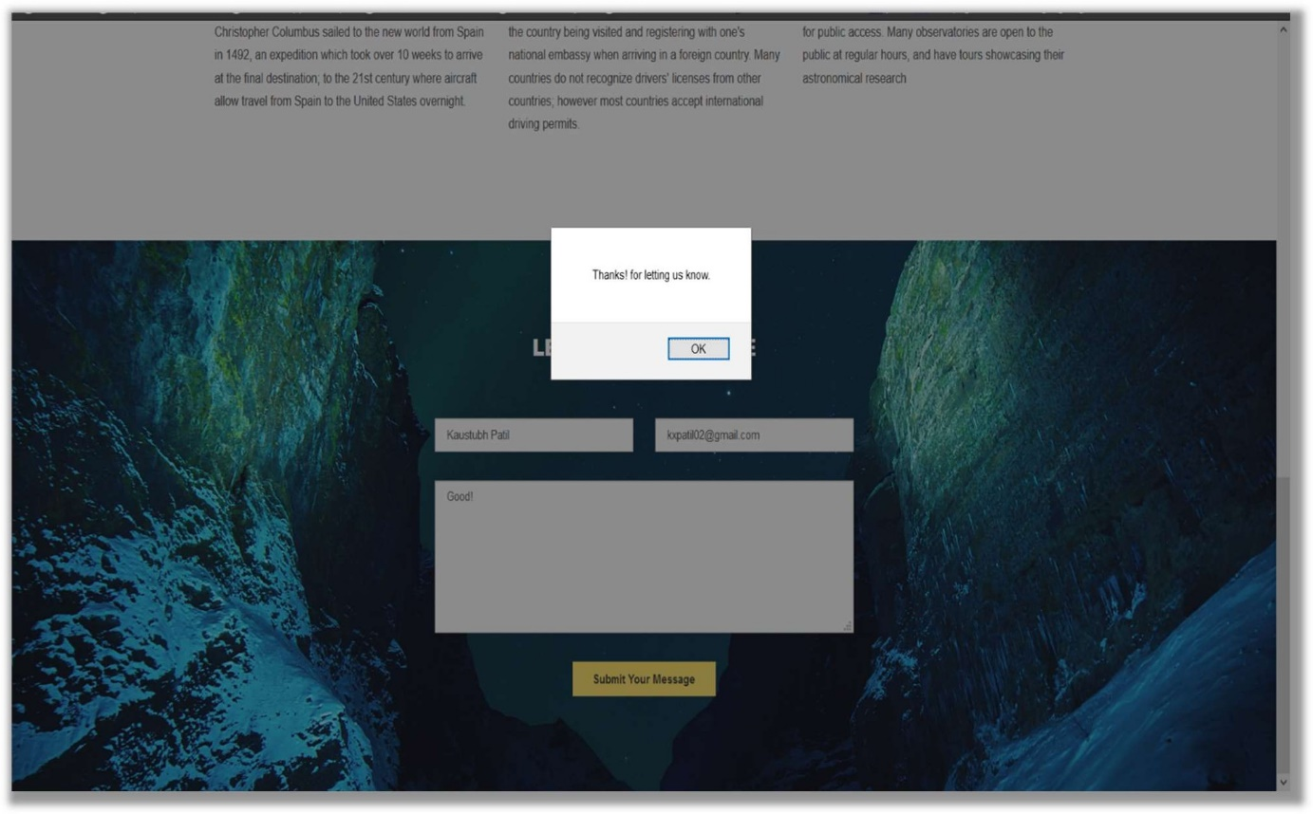

CONCLUSION

Thus, we have successfully created a website for tourism and travelling purpose. By using languages as: html, javaScript, Css and bootstrap themes. In this website we have categorized different countries and amazing places from different continents, also travelling a oneway trip or a round trip that depends on the user accessing website. We have used VsCode Editor, that helped us to ease our work.

REFERENCE

https://fonts.googleapis.com/css https://[www.youtube.com/watch?v=5iC9gyAdEV0](http://www.youtube.com/watch?v=5iC9gyAdEV0) bootstrap.min.css

bootstarp-theme.css & style.css https://[www.wix.com/html5](http://www.wix.com/html5) https://[www.w3schools.com/html/html_css.asp](http://www.w3schools.com/html/html_css.asp) https://[www.w3schools.com/html/html_styles.asp](http://www.w3schools.com/html/html_styles.asp) https://[www.w3schools.com/html/html_images.asp](http://www.w3schools.com/html/html_images.asp) https://[www.youtube.com/watch?v=K4aa7ruovg0](http://www.youtube.com/watch?v=K4aa7ruovg0)